Cell Simulation
#1: Nucleus: Has binder with a color copy (DNA with specific genes on a chromosome) of the legos and where they should go. Uses a photocopy (mRNA) of correct shape and colors it to show how it is to be made. Copies get passed over to ER and ribosomes.

RNA: Delivers the copies of instructions to the ribosomes.
#2: Ribosomes: Has a box of Legos. Takes the copied instructions to make various objects. Sits at a chair in the ER (or at a desk free floating)

#3: ER: Maze of tables from nucleus. Some have chairs for ribosomes. Sorts the proteins into different locations. Give a chart with what type of protein goes where. Adds a tag with a piece of tape to tell the Golgi where to send it.
#4: Golgi: Puts objects into packages and writes down where they go.

#5: Vesicles: Take packages to the correct location using tape on floor.

Cytoskeleton: Tape along the floor that directs movements around the cell.

Cell membrane: Controls what goes in and out of cell. Won’t let in harmful things in. Guards the door to classroom.

#6: Lysosome: Looks for broken or incorrect proteins. Recycles the parts and puts them back into use. Collects the used up pieces from the organelles, removes tape and breaks pieces. Puts back into the ribosome box of Legos.

#7: Mitochondria: Takes the box of cereal and puts into small containers that are delivered to the various organelles. Each time an organelle has completed their job, they require an energy supplement to do another round.
Nucleus | 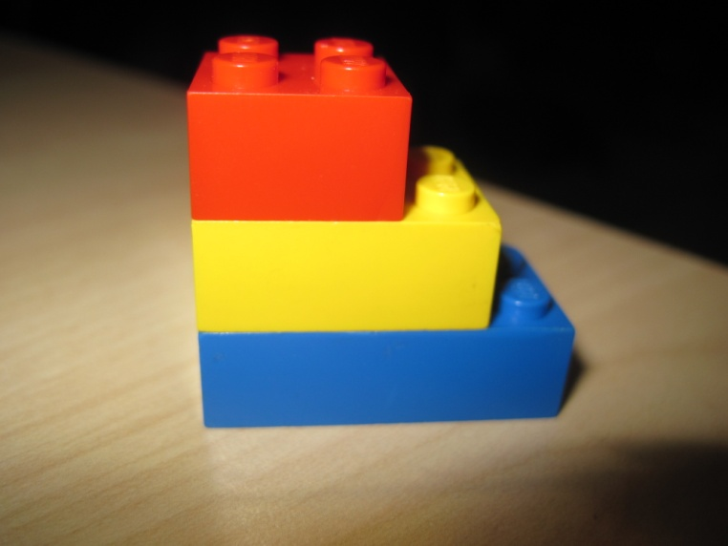
Mitochondria | 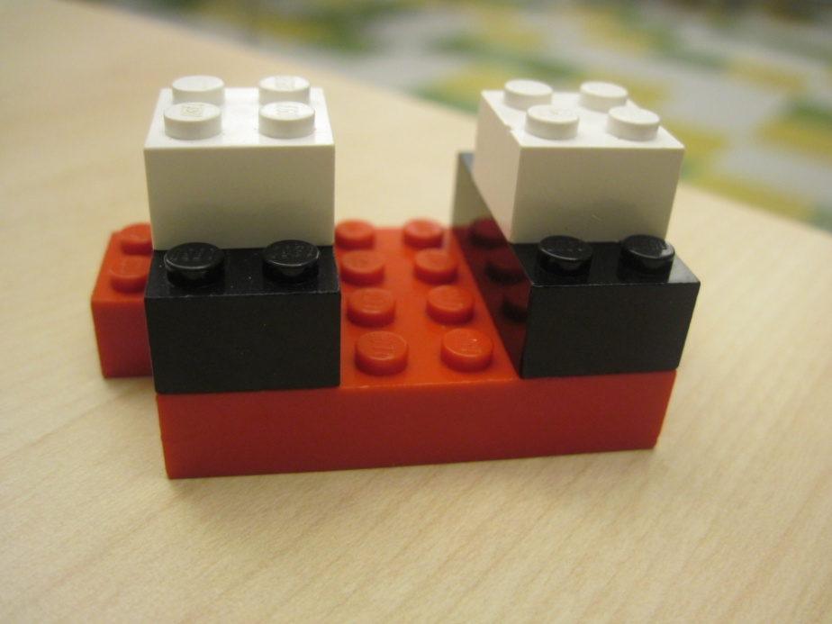
ER | 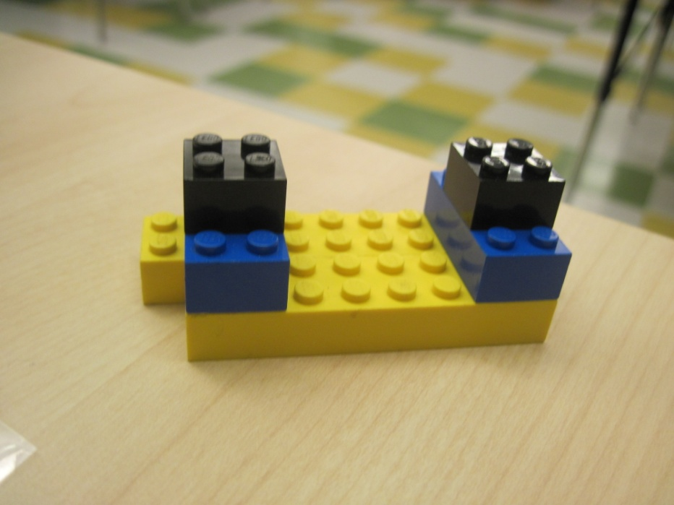
Ribosome | 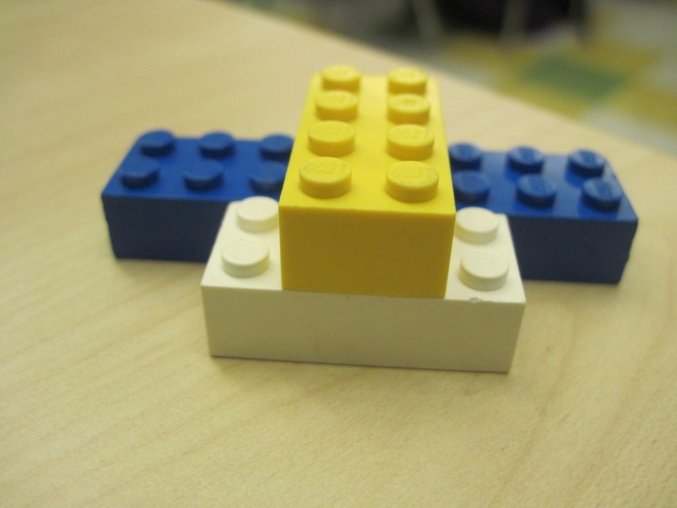
Golgi bodies | 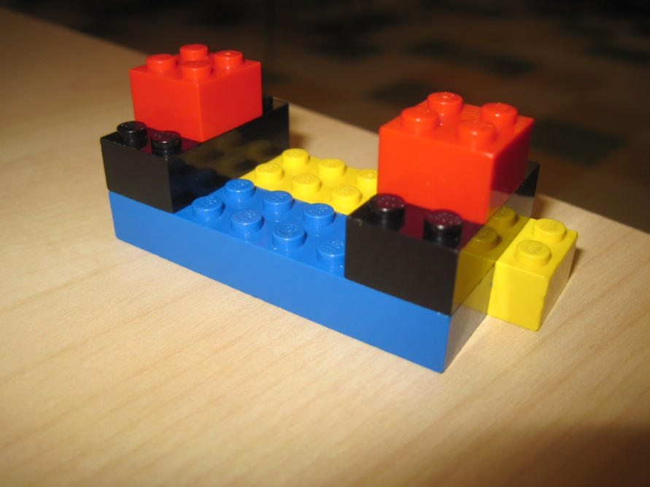
Cell membrane | 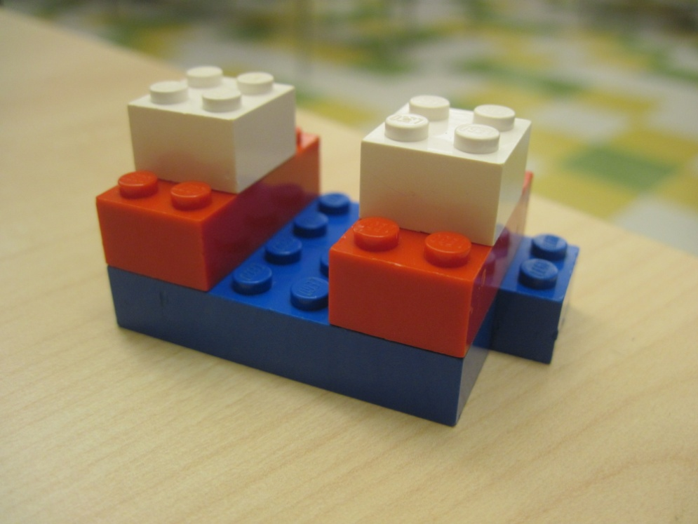
Lysosome | 