**Effects of Earthquakes on Buildings**

**In-Class Activity and Teacher’s Guide**

By LeAnne Teruya

Bay Area Earth Science Institute

120511

**Introduction:**

Each earthquake creates it’s own unique pattern of shaking and intensity—a “signature” of sorts. For example, one earthquake may be short and severe, while another may last longer but feel less intense. Likewise, one earthquake may damaged certain buildings, but not others. *What determines the amount of damage a building will receive in an earthquake?*

This activity demonstrates the effects of seismic frequency on building height. Three buildings of similar construction are used to compare the effects of slow, medium, and fast shaking.

**Learning Objectives:**

Through this activity, students will discover that

* buildings of any height can be damaged by an earthquake
* different seismic frequencies have greater effect on different building heights
* faster frequencies have greater effect on short buildings
* the slowest frequencies have the greatest impact on the tallest buildings

**Materials List*:**

Each group will need the following:

1 file folder

9 file folder strips (1½”wide x 1111/16” long**)

18 pieces of tape, stickers, or labels for constructing the buildings

*All the materials for this activity can be purchased at RAFT (Resource Area for Teachers) where boxes or rolls of labels and used file folders are always available. Thick card stock will also work fine.

**1111/16” is the width of a letter size file folder.

**Background:**

Damage to buildings as a result of earthquakes is determined largely by three factors: building construction, the type of geology beneath the buildings, and the frequency of the seismic waves.

**Construction**—

Building materials used and the quality of construction can determine how much damage is sustained in an earthquake and whether or not a building becomes damaged at all.

**Geology**—

What’s beneath the building is very important! Some types of rocks absorb seismic waves, lessening the effects of the earthquake. Other rock types and thick accumulations of sediment allow seismic waves to pass through easily resulting in greater shaking from the earthquake.

**Frequency of the seismic waves—**

Wave frequency refers to how closely spaced the seismic waves are. We experience seismic wave frequency as shaking during an earthquake. The more closely spaced the wave peaks are, the faster the wave is travelling and the more quickly the ground shakes. How fast or slow a seismic wave travels is determined by the amount of energy released by the earthquake, the type of geological material the seismic waves travel through, and how far from the epicenter the seismic waves have travelled.

**Topics for further discussion:**

* What are the effects of aftershocks? How is it be possible that an smaller aftershock could topple a building that withstood the larger main earthquake?
* Why isn’t the tallest building affected by earthquakes with the faster frequencies?
* How can construction be changed/improved to prevent so much shaking or swaying in the buildings?
* How is it possible for an earthquake with a relatively small magnitude to cause more damage than a larger earthquake?

**Helpful Hints:**

* All the buildings need to have similar construction and face the same direction in order to achieve the most comparable results.
* Construction—quality, consistency, and speed—will be easier if fold lines are pre-drawn on the strips. Draw fold lines on the folders before cutting the strips.



**Group Activity: The Effects of Earthquakes on Buildings**

**Background: *What determines the amount of damage a building will receive in an earthquake?***

**Construction**—

Building materials used and the quality of construction can determine how much damage is sustained in an earthquake and whether or not a building becomes damaged at all.

**Geology**—

What’s beneath the building is very important! Some types of rocks absorb seismic waves, lessening the effects of the earthquake. Other rock types and thick accumulations of sediment allow seismic waves to pass through easily resulting in greater shaking from the earthquake.

**Frequency of the seismic waves—**

Wave frequency refers to how closely spaced the seismic waves are. We experience seismic wave frequency as shaking during an earthquake. The more closely spaced the wave peaks are, the faster the wave is travelling and the more quickly the ground shakes. How fast or slow a seismic wave travels is determined by the amount of energy released by the earthquake, the type of geological material the seismic waves travel through, and how far from the epicenter the seismic wave is.

**Instructions:**

1. Fold each paper strip along the lines so that a boxy “U” shape is formed from three sides of equal length:

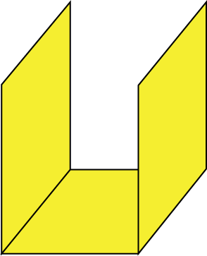

1. Take three folded strips. Make three “foundation” pieces by folding the sides into the lines as shown below:

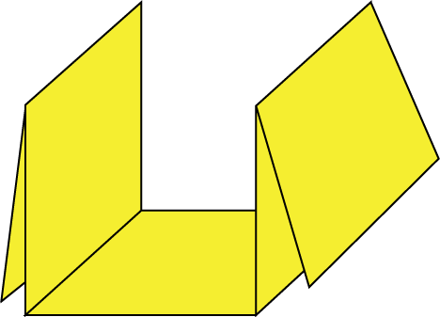

1. Tape the three foundation pieces to the folder so that all the buildings will be facing the same direction.

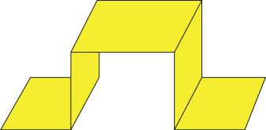

1. Now tape the rest of the strips to the foundation pieces so that you have 3 buildings with similar construction according to the list below:

|  |  |
| --- | --- |
| Short = 2 story  Medium = 3 story  Tall = 4 story | 2-Story bldg.png |

1. Which building do you predict to be the safest in an earthquake?
2. Shake the folder back-and-forth at different frequencies (fast and slow, hard and softly)and observe how the buildings are affected.
3. Which building is the safest?