THE GREAT FOSSIL FIND ¹

You and your team of fellow paleontologists are working in the field in Montana, near the town of Ekalaka. At the end of the first day, you and your team find eight well-preserved and complete fossil bones.
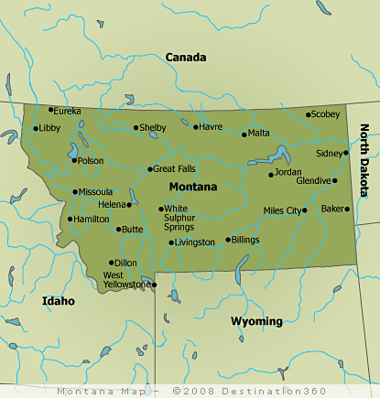
OPEN THE DAY 1 ENVELOPE AND REMOVE THE EIGHT FOSSILS.

DAY 1. That night in camp, you and your team begin to assemble the eight bones you found that day. Because the bones were all found together in an undisturbed layer of sedimentary rock, you assume that they are all from the same animal. You spend the rest of the evening trying different arrangements of the bones in hopes of identifying the animal before you can’t stay awake any longer.
Ekalaka

Take 5 mins. to assemble the bones and make notes in your data chart. What kind of animal do you think this is?

DAY 2. You wake up and hurry back out to the dig site. The rock layers that hold the fossils are very hard, but you and your team are able to uncover seven more fossils, presumably from the same animal. As the day ends, you make your way back to camp for another try at assembling the mystery animal.

OPEN THE DAY 2 ENVELOPE AND REMOVE THE SEVEN FOSSILS.
Take 5 mins. to incorporate the seven new fossils into yesterday’s assembly. You may want to compare your findings with a nearby team. Make notes in your data chart. Now, what kind of animal do you think this is?

DAY 3. This is the last day of digging season, and your last chance to find more fossils from the mystery animal. Just as the day is about to end, you and your team find six more fossils.

OPEN THE DAY 3 ENVELOPE AND REMOVE THE SIX FOSSILS.

Take 5 mins. to incorporate the six new fossils into the assembly. Make notes in your data chart. Now, what kind of animal do you think this is?

DAY 4. You and your team head back home to your campus laboratory and reference resources. The sponsor of your expedition, Lucas Spielberg, is demanding to see the assembled fossil skeleton and your data table/notes by the end of the day.

Use the reference resources to help you in your final assembly of the fossil skeleton. Fill in your data table with your final interpretation of the skeleton.

If you need additional resources to help you accurately complete your final assembly before the expedition sponsor arrives, you will need access to the special, top-secret paleontological archives at CSU East Bay. Please notify Dr. Inouye of your urgent situation, and she will give you instructions on how to get the resources you need ASAP.

¹ This activity has been adapted from Indiana University’s Evolution & the Nature of Science Institutes, www.indiana.edu/~ensiweb/lessons/gr.fs.fd.html.

THE GREAT FOSSIL FIND – DATA REPORTING SHEET

Complete the table below. One copy per team will need to be shown to the expedition sponsor.

 | DAY 1 | DAY 2 | DAY 3 | DAY 4
What types of fossils/bones do you think you’ve uncovered?

What type of animal do you think you’ve discovered?

How and where did this animal live?

Questions for Discussion

1. Did you make any assumptions at the beginning of the activity that made it harder for you to assemble the fossil bones? If so, explain.

2. Did the discovery of new bones cause any conflict within your team? Why or why not?

3. What information did you get from another team? How did it influence your assumptions?

4. Did the reference resources confirm your team’s ideas or did they cause your team to rework the arrangement of the fossil bones? Explain.

5. Do you think this activity would have been easier or harder to do alone? What about with more than two people?

6. Do you think the “Fossil Find” scenario is typical of how scientists work, i.e., create and revise hypotheses?

7. Is it possible for scientists to perform studies about events that happened millions of years ago? Explain.

8. What do you think were the three main goals of this activity?

