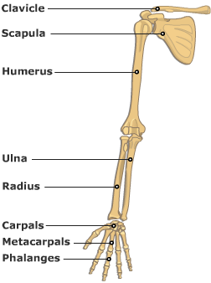
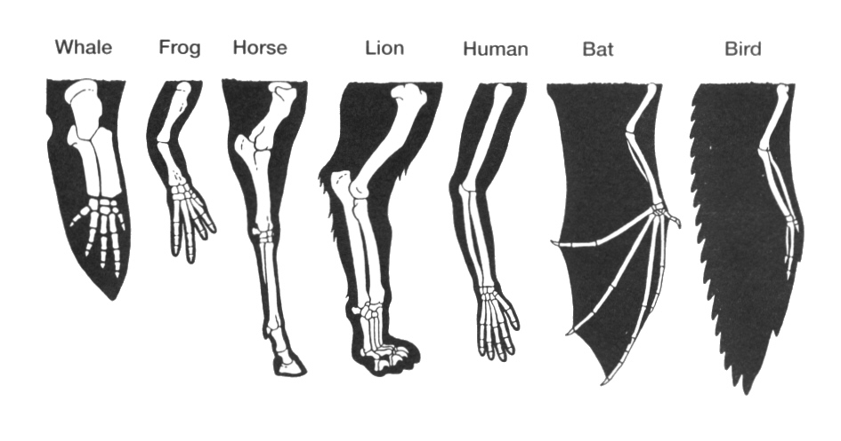
Color code the following bones in each of the forelimbs above
using the following color scheme:
  - Humerus = orange
  - Radius = red
  - Ulna = purple
  - Carpals = green
  - Metacarpals = pink
  - Phalanges = yellow

