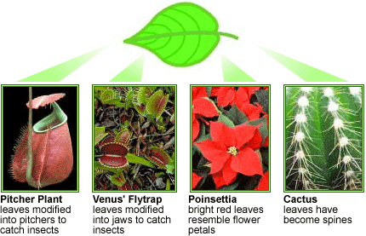

The Plant Leaf

The leaves of plants show a variety of shapes and functions. Look at the different plant leaves at this display.

- Are the leaves of plants homologous or analogous structures? Explain.

- Why do you think the Pitcher Plant and Venus’ Flytrap evolved leaves that trap insects?

- What are the functions of the
  - Pine leaves?
  - Poinsettia’s bright red leaves?
  - Cactus spines?
  - Grape plant tendrils?
  - Ice plant fleshy leaves?

Answers:

- Leaves exhibit a variety of shapes and functions, yet all are homologous structures, because leaves are derived from a common ancestral form.

- The Pitcher Plant and Venus’ Flytrap leaves trap and digest insects. This strategy is an adaptation for nitrogen-poor environments, as insects provide a rich source of protein (thus nitrogen).

- As in most green leaves, ivy leaves are the main sites of photosynthesis for the plant.

- The bright red leaves of the Poinsettia look and function like flower petals, so function to attract pollinators. These leaves are non-photosynthetic.

- Cactus spines function to reduce water loss (minimizes surface area) – an adaptation for arid climates - and can protect the cactus from herbivory.

- Tendrils help anchor the plant, so that it can climb/grow up their supports.

- The fleshy leaves of the ice plant serve to store water (and sugars) as an adaptation for arid climates.

VERTEBRATE FORELIMBS

Tetrapod vertebrates (those with four limbs, i.e., amphibians, reptiles, birds, and mammals) all have differently shaped forelimbs, reflecting their different lifestyles. Look at the forelimb skeletons in the display.

- Are the bones of tetrapod forelimbs homologous or analogous structures? Explain.

- What is the function of each of the displayed forelimbs?

- Try to identify the same forelimb bones in all the vertebrate skeletons, particularly the
  - Humerus – upper arm bone, extending from shoulder to elbow
  - Radius – one of the two forearm bones, extending from elbow to the thumb side of the wrist
  - Ulna – one of the two forearm bones, extending from the elbow (the bony point of the elbow is actually the tip of the ulna) to the pinky side of the wrist.
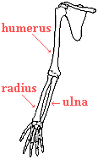

Answers:
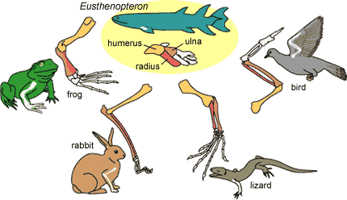
- The different forelimbs all share the same set of bones, so the tetrapod forelimb bones are homologous structures. These same bones are seen in fossils of extinct common ancestors, such as Eusthenopteron, a lobe-finned fish.

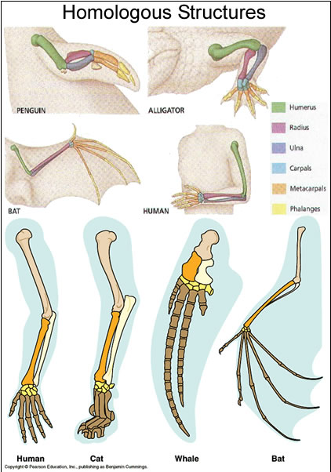

WINGS

Many different animals have evolved wings for flying. Look at the variety of wings on display.

- Do you think the wings displayed are homologous or analogous structures? Explain.

- Birds and bats are both tetrapod vertebrates. Are the wings of birds and bats homologous or analogous structures? Explain.

Answers:

- Wings are analogous structures. Even though they serve the same function, wings evolved independently (through convergent evolution) after their point of common ancestry, meaning that they were not inherited from a common ancestor. Wings are superficially similar, because they have similar function (play a key role in flight), but the various wings are structurally very different.

- Even though the forelimb bones of birds and bats are homologous, their wings are analogous. Birds and bats did not inherit wings from a common ancestor with wings, but they inherited forelimbs from a common ancestor with forelimbs. Bat wings consist of flaps of skin stretched between the bones of the fingers and arm. Bird wings consist of feathers extending all along the arm.

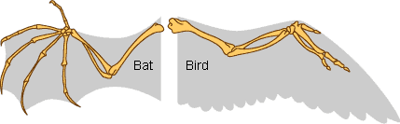

HORSE EVOLUTION

The skull, teeth, body size, and feet of horses reveal a fascinating trend in horse evolution revealed from fossils from the past 50 million years. Look at the fossil casts of horse teeth on display.

- What does horse tooth shape and size tell you about the diet of ancestral horses compared to modern day horses?

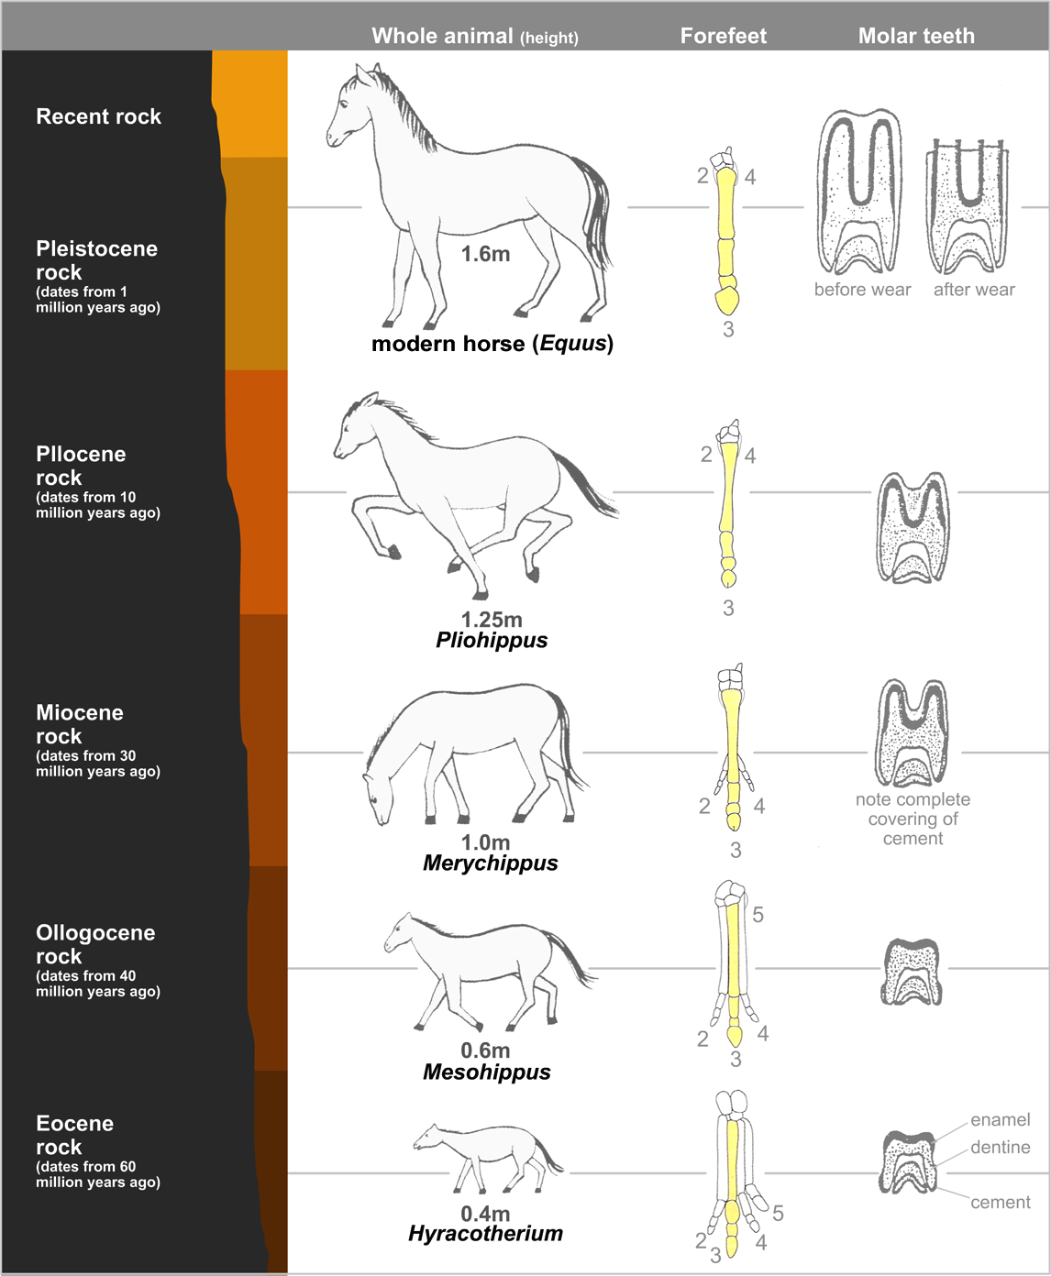
- Why would the diet of ancestral horses be different from that of modern day horses?

ANSWERS:

- Early horse ancestors fed mostly on leaves in lush forests. As the climate began to become more arid, horse diet shifted from foliage to shrubs to grasses. Grasses are high in silica, which is very abrasive and causes rapid wear of the teeth. Thus, horse teeth evolved to become larger, more durable, and more ridged to increase surface area for grinding the gritty grasses.

- Diet changed because climate changed. Horse habitats shifted from moister, lusher forests to more dry grasslands.

