The Floating Leaf Disk Assay for Investigating Photosynthesis

(A resource page)

Brad Williamson

Introduction:
Trying to find a good, quantitative procedure that students can use for exploring photosynthesis is a challenge. The standard procedures such as counting oxygen bubbles generated by an elodea stem tend to not be “student” proof or reliable. This is a particular problem if your laboratory instruction emphasizes student-generated questions. Over the years, I have found the floating leaf disk assay technique to be reliable and understandable to students. Once the students are familiar with the technique they can readily design experiments to answer their own questions about photosynthesis.

The biology behind the prodedure:
Leaf disks float, normally. When the air spaces are infiltrated with solution the overall density of the leaf disk increases and the disk sinks. The infiltration solution includes a small amount of Sodium bicarbonate. Bicarbonate ion serves as the carbon source for photosynthesis. As photosynthesis proceeds oxygen is released into the interior of the leaf which changes the buoyancy--causing the disks to rise. Since cellular respiration is taking place at the same time, consuming oxygen, the rate that the disks rise is an indirect measurement of the net rate of photosynthesis.
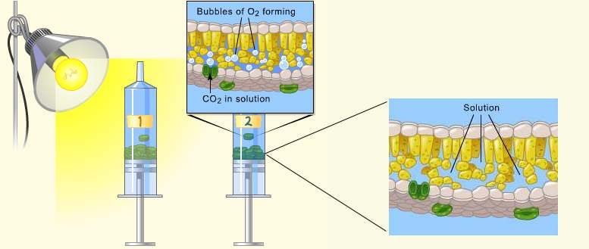

Materials:
- Sodium bicarbonate (Baking soda)
- Liquid SoapPlastic syringe (10 cc or larger)—remove any needle!
- Leaf material
- Hole punch
- Plastic cups
- Timer
- Light source

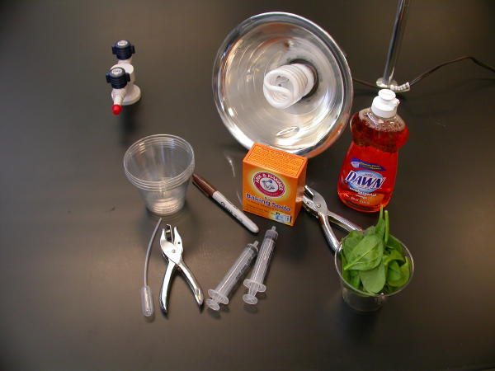

Optional:
- Buffer Solutions
- Colored Cellophane or filters
- Leaf material of different ages
- Variegated leaf material
- Clear Nail polish

Procedure:
- Prepare 300 ml of bicarbonate solution for each trial.
  - The bicarbonate serves as an alternate dissolved source of carbon dioxide for photosynthesis. Prepare a 0.2% solution. (This is not very much it is only about 1/8 of a teaspoon of baking soda in 300 ml of water.)
- Add 1 drop of dilute liquid soap to this solution. The soap wets the hydrophobic surface of the leaf allowing the solution to be drawn into the leaf. It’s difficult to quantify this since liquid soaps vary in concentration. Avoid suds. If your solution generates suds then dilute it with more bicarbonate solution.
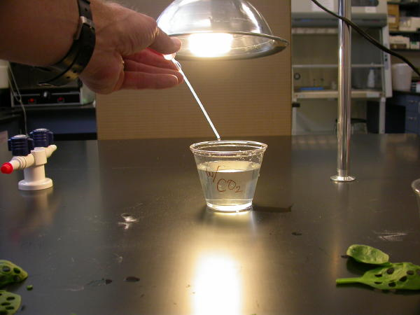
- Cut 10 or more uniform leaf disks for each trial.
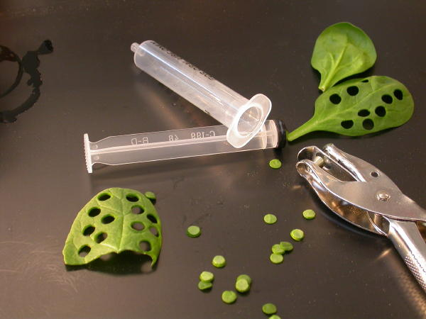
  - Single hole punches work well for this but stout plastic straws will work as well.
  - Choice of the leaf material is perhaps the most critical aspect of this procedure. The leaf surface should be smooth and not too thick. Avoid plants with hairy leaves. Ivy, fresh spinach, Wisconsin Fast Plant cotyledons--all work well. Ivy seems to provide very consistent results. Many different plant leaves work for this lab. My classes have found that in the spring, Pokeweed may be the best choice.
  - Avoid major veins.
- Infiltrate the leaf disks with sodium bicarbonate solution.
  - Remove the piston or plunger and place the leaf disks into the syringe barrel. Replace the plunger being careful not to crush the leaf disks. Push on the plunger until only a small volume of air and leaf disk remain in the barrel (< 10%).
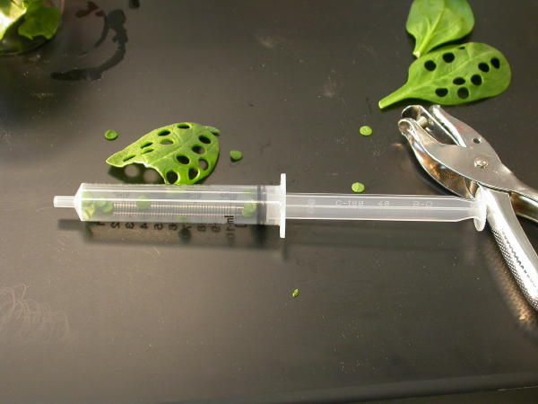
  - Pull a small volume of sodium bicarbonate solution into the syringe. Tap the syringe to suspend the leaf disks in the solution.
  - Holding a finger over the syringe-opening, draw back on the plunger to create a vacuum. Hold this vacuum for about 10 seconds. While holding the vacuum, swirl the leaf disks to suspend them in the solution. Let off the vacuum. The bicarbonate solution will infiltrate the air spaces in the leaf causing the disks to sink. You will probably have to repeat this procedure 2-3 times in order to get the disks to sink. If you have difficulty getting your disks to sink after about 3 evacuations, it is usually because there is not enough soap in the solution. Add a few more drops of soap.
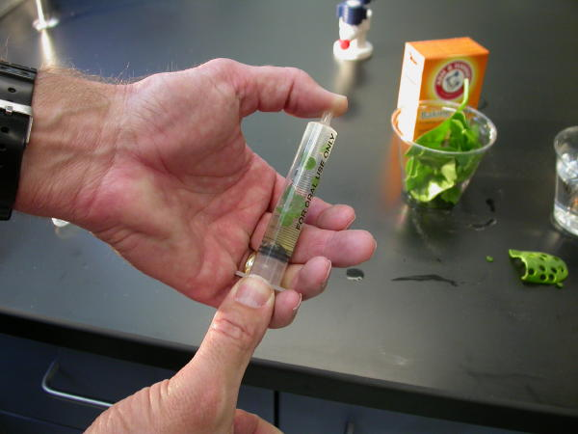

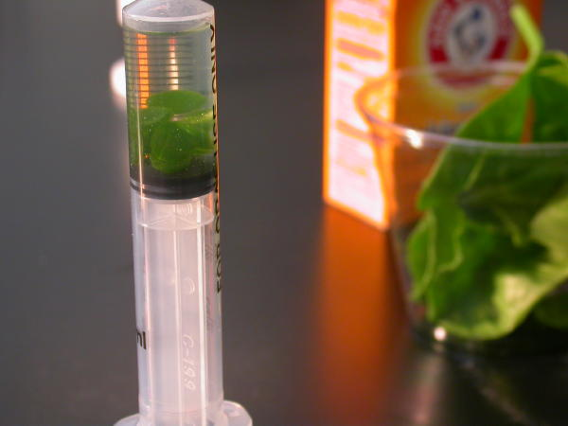
- Pour the disks and solution into a clear plastic cup. Add bicarbonate solution to a depth of about 3 centimeters. Use the same depth for each trial. Shallower depths work just as well.
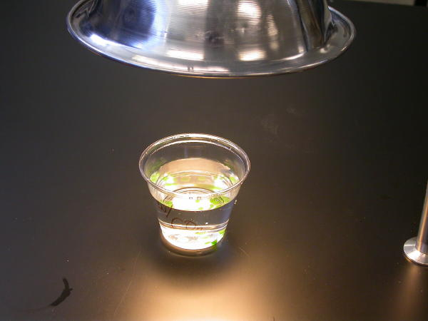
- For a control infiltrate leaf disks with a solution of only water with a drop of soap--no bicarbonate.
- Place under the light source and start the timer. At the end of each minute, record the number of floating disks. Then swirl the disks to dislodge any that are stuck against the sides of the cups. Continue until all of the disks are floating.
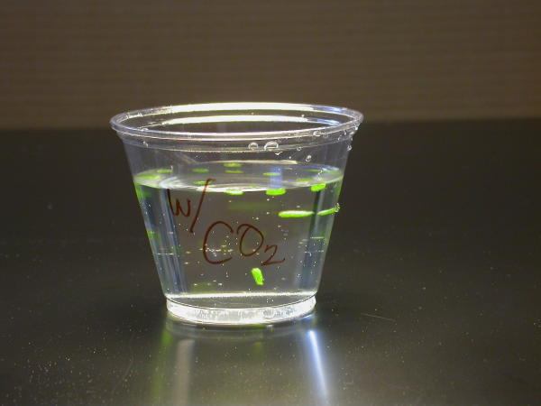

Data Collection and Analysis
These data are from a demonstration investigation using grape ivy leaf disks.
Minutes | Disks
1 | 0
2 | 0
3 | 0
4 | 0
5 | 0
6 | 0
7 | 1
8 | 1
9 | 1
10 | 1
11 | 4
12 | 7
13 | 8
14 | 10
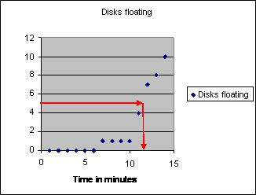
The point at which 50% of the leaf disks are floating (the median) is the point of reference for this procedure. By extrapolating from the graph, the 50% floating point is about 11.5 minutes. Using the 50% point provides a greater degree of reliability and repeatability for this procedure. As Steucek, et. al. (1985) described this term is referred to as the ET50.

The problem with ET50 is that it goes down as the rate of photosynthesis goes up--it is an inverse relationship and creates the following type of graph (data from Steucek, et al. 1985.):
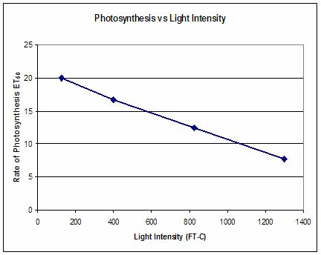
To correct for this representation of the data and present a graph that shows increasing rates of photosynthesis with a positive slope the ET50 term can be modified by taking the inverse or 1/ET50. This creates a graph like this(data from Steucek, et al. 1985.):
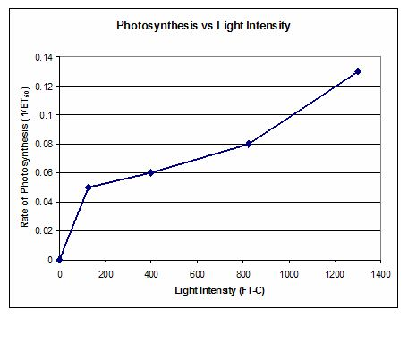
Extension:
In this graph, the light was turned off at 14 minutes and the cups with their floating disks (grape ivy) were placed in the dark.
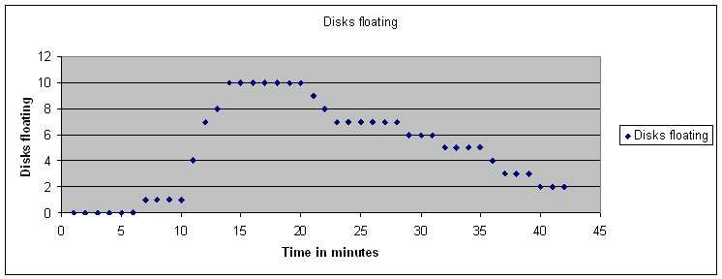
Every minute, I removed the dark cover and counted how many were still floating. Then I stirred the disks. Note that after a while the disks begin to sink. Why? Cellular respiration removes the oxygen from the cell spaces. The rate that the disks sink is an indirect measure of the rate of cellular respiration. Can you think of a way to how you might measure the gross rate of photosynthesis with this technique?

Print and Web Resources:
Wickliff, J.L. and Chasson, R.M. 1964. Measurement of photosynthesis in plant tissues using bicarbonate solutions. Bioscience, 14: 32-33.
Steucek, Guy L. Robert J. Hill and Class/Summer 1982. 1985. Photosynthesis I: An Assay Utilizing Leaf Disks. The American Biology Teacher, 47(2):96-99.
Tatina, Robert E. 1986. Improvements to the Steucek and Hill Assay of Photosynthesis. The American Biology Teacher, 48(6): 364-366.
Juliao, Fernando and Henry C. Butcher IV. 1989. Further Improvements to the Steucek and Hill Assay of Photosynthesis. The American Biology Teacher, 51(3): 174-176.
Armstrong, Joeseph E. 1995. Investigation of Photosynthesis using the Floating Leaf Disk Assy. http://www.bio.ilstu.edu/Armstrong/biolab/cellbio/psynex1.htm
Rukes, Kari L. and Timothy J.Mulkey. 1994. Measurement on the Effects of Light Quality and Other Factors on the Rate of Photosynthesis. Bioscene, 20(3): 7-11. http://www.acube.org/volume_20/v20-3p7-11.pdf
Greenler, John. 1990. Exploring Photosynthesis with Fast Plants. WisconsinFast Plant Notes, 4(1): 4-5. http://www.fastplants.org/pdf/activities/exploring_photosynthesis.pdf
BioPi listserv archives. http://listserv.ksu.edu/archives/biopi-l.html
Enter the "Leaf Disks" for a search to review a thread on the technique. Dan Mott attached a copy of his lab using this technique to one of his postings.

